# **Virtual Machine (VM)**

## What is a Virtual Machine?

A Virtual Machine (VM) is a software-based computer that runs inside another physical computer. It behaves like a real computer and can run its own operating system (OS) and applications. The main computer is called the host, and the virtual machine running inside it is called the guest.

VMs are created and managed using special software called a hypervisor. Popular hypervisors include VirtualBox, VMware, and Microsoft Hyper-V.

## Simple Definition

A virtual machine is like a computer inside your computer. It lets you run different operating systems and software without changing or damaging your actual computer.

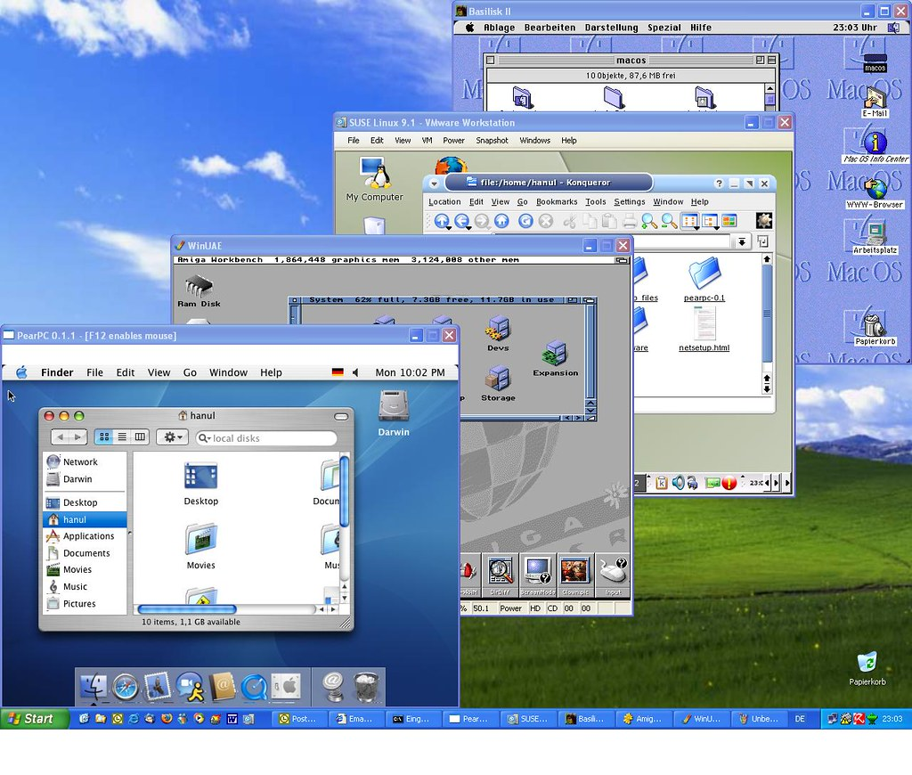

## Examples of Use

1. Trying a New Operating System – You can install and explore different operating systems (like Linux or older versions of Windows) safely inside a VM.

2. Testing Applications – Developers can test apps or new software in a VM before using them on their real systems.

3. Running Old Applications – Some old software doesn’t work on modern systems, but it can run inside a virtual machine with an older OS.

4. Learning and Practicing – Students can use VMs to practice coding, system setup, or networking without affecting their main computer.

5. Creating Isolated Environments – You can separate personal and work setups. If something goes wrong in the VM, your main computer stays safe.

6. Taking Snapshots – VMs allow you to take 'snapshots' of their current state. If something breaks, you can easily restore the VM to a working condition.

## Advantages of Virtual Machines

* Safety – Isolated from the main system, reducing the risk of malware or errors.
* Flexibility – Run multiple OSes on one machine.
* Cost-effective – No need for extra physical hardware.
* Portability – VM files can be moved from one computer to another.
* Easy to reset – Mistakes made while experimenting can be fixed quickly.

## What is a Hypervisor?

A hypervisor is special software that allows you to create and run virtual machines (VMs). It acts as a bridge between your computer’s hardware and the virtual machines. Without a hypervisor, VMs cannot work.

In simple words: Hypervisor = VM manager. It divides your computer's resources and gives them to each virtual machine.

## Types of Hypervisors

1. Type 1 Hypervisor (Bare Metal) – Runs directly on hardware. Faster and used in data centers. Examples: Microsoft Hyper-V, VMware ESXi, KVM.

2. Type 2 Hypervisor (Hosted) – Runs on top of your existing OS. Easy to use. Examples: VirtualBox, VMware Workstation.

## Functions of a Hypervisor

• Creates and manages VMs

• Distributes hardware resources (RAM, CPU, etc.)

• Isolates each VM

• Allows snapshot and restore features

## Why Hypervisors Are Important

They help you run many systems on one device and are useful for developers, testers, students, and IT professionals. They also save money by avoiding the need for multiple computers.

CONCLUSION

Virtual Machines are powerful tools that help us run multiple operating systems and applications on a single physical computer. Whether you're a student learning new skills, a developer testing software, or someone who wants to explore different operating systems safely, VMs offer flexibility, security, and cost savings.

With the help of hypervisors, managing and using virtual machines has become easier than ever. Understanding VMs is an important step for anyone interested in technology, software